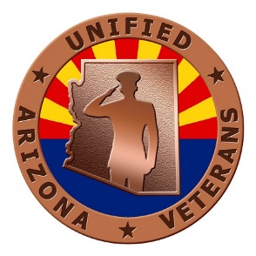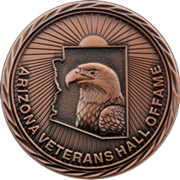
THIS FORM IS FOR MAIL-IN REGISTRATION ONLY
The only method of payment is by check or money order. Please print and complete this form, mailing the 2ND page along with a check or money order payable to:
"Unified Arizona Veterans" at the following address.

Unified Arizona Veterans
Attn: Treasurer
P. O. Box 34338
Phoenix, AZ 85067

Be sure to include "AVHOF" in the “For” section of the check.

DATE AND LOCATION
Friday, October 26th, 2018
Talking Stick Resort – Scottsdale
9800 E Talking Stick Way (Indian Bend Exit), Scottsdale, AZ 85250
PROGRAM
Social Time 10:30 am – 11:20 am
Ballroom doors open at 11:00 am
Opening ceremony and remarks 11:30 am – 11:50 pm
Lunch 11:50 pm – 12:50 pm
Break 12:50 pm – 1:00 pm
Induction ceremony 1:00 pm – 2:30 pm

MENU (pending)
Chicken Breast
Salad, Potatoes, Green Beans, New York Cheesecake
Special dietary needs accommodated by prior arrangements only – see registration form
REGISTRATION and PAYMENT
Registration received on or before September 30th is $55 / attendee;
Registration received on or after October 1st until registration closes at 4:30 pm on Oct 12th is $65
Registration, medical dietary needs, accessibility needs, and payment instructions are on the next page.
NO PAYMENTS, NOR WALK-INS, WILL BE ACCEPTED AT THE EVENT

DRESS - Business (Honorees and all guests)
Gentlemen: Coat and Tie
Ladies: Dress or Suit

GUEST REGISTRATION FORM – ARIZONA VETERANS HALL OF FAME INDUCTION CEREMONY
CONTACT INFORMATION ON INDIVIDUAL PROVIDING INFORMATION FOR THIS FORM
(all blocks above dotted line are mandatory)
TITLE OR RANK: ___________ FIRST NAME: ____________________ LAST NAME: _______________________
NUMBER & STREET: ____________________________ CITY: ___________________ STATE: ____ ZIP: _________
TELEPHONE: (_____) ______-___________ EMAIL ADDRESS: __________________________________________
SEATING PREFERENCE (Inductee or Organization): ___________________________________________________
- - - - - - - - - - - - - - - - - - - - - - - - - - - - - - - - - - - - - - - - - - - - - - - - - - - - - - - - - - - - - - - - - - - - - - - - - - - - - - - - - - - - - - -
If you do not fill a table of 10, other guests will be assigned to sit with you.
1st Attendee: _____________________________ Dietary/Wheelchair Needs: ________________________________
2nd Attendee: ____________________________ Dietary/Wheelchair Needs: ________________________________
3rd Attendee: ____________________________ Dietary/Wheelchair Needs: ________________________________
4th Attendee: ____________________________ Dietary/Wheelchair Needs: ________________________________
5th Attendee: ____________________________ Dietary/Wheelchair Needs: ________________________________
6th Attendee: ____________________________ Dietary/Wheelchair Needs: ________________________________
7th Attendee: ____________________________ Dietary/Wheelchair Needs: ________________________________
8th Attendee: ____________________________ Dietary/Wheelchair Needs: ________________________________
9th Attendee: ____________________________ Dietary/Wheelchair Needs: ________________________________
10th Attendee: ___________________________ Dietary/Wheelchair Needs: ________________________________
EARLY BIRD COST FOR MEALS - $55 RECEIVED AFTER SEPTEMBER 30TH - $65

Check or money order made out to "Unified Arizona Veterans" and mailed to:

Unified Arizona Veterans
Attn: Treasurer
P. O. Box 34338
Phoenix, AZ 85067

Be sure to include "AVHOF" in the "For" section of the check.
R.S.V.P. must be received by 4:30 pm, Friday, 12 October 2018

QUESTIONS?
Anyone incurring difficulty registering for this event can call the point of contacts listed below.
POC: Sue Wudy (registration, meals, accessibility accommodations) 602-277-4168 lilsarge@mindspring.com
POC: Carol Culbertson (for all other inquiries) 602-799-9480 secretary@azuav.org

